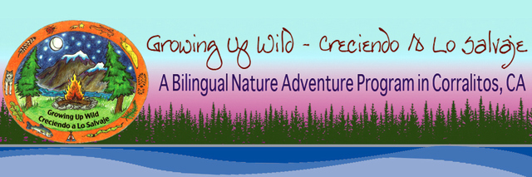

What Can We Do At Camp Cruz?
Camp is Cruz is a one of a kind campground with many outdoor possibilities and camp comforts. Our 4-acre campground is like a campground retreat center. It is equipped with an outdoor kitchen on a large deck. The kitchen has running potable water, electricity, grills, kitchen supplies, and storage. Camp Cruz offers a 22 ft. furnished geodesic dome with a woodstove. It has two comfortable composting toilets and two hot showers. It has a play structure area for young children and room for them to run around safely without any worry about roads or traffic. Our camp has a perennial creek running through it with safe access for all ages. Our land is a seasonal native habitat for ladybugs. We have a native plant and seasonal vegetable landscaped garden. Camp Cruz has plenty of flat space in the woods for tents and privacy. We have sufficient space for parking.
Within a few short minutes from our camp are three very cool attractions for outdoor activities. One is that we are just 2 miles below the upper trailhead of the Forest of Nisene Marks State Park. This wilderness park is a mecca for mountain bike riding, hiking, and nature studies. One mile below our camp is a little-known public wild land owned by the city of Watsonville. It is a perfect place for day hikes, picnics, and creek studies. Right next to this wild land is the Koinonia Conference Grounds where high ropes course adventures are available year-round for scheduling.
Our camp is located on Eureka Canyon Road and can reached from two different directions. One is from the Highway 1 Santa Cruz/Watsonville area on the Central Coast. Drive time is about 40 minutes from Santa Cruz. The other direction is from Summit Road off of Highway 17. The Summit Road route makes our camp easily accessible to Bay Area groups since the drive generally takes no more than one hour from San Jose.

